Consider a middle position. If the seller needs some cash but you want structural safety, drop the cash to $250-300K, around 8-10%. That gives comfortable reverse-triangular margin even if the common valuation comes in soft, keeps liquidity on the table, preserves a cash escrow, and costs the seller only ~$60-70K of tax instead of $119K. That may be the actual answer.

Avoid a seller note. A note is boot in a reorg, it counts against the 20% ceiling, and the installment sale interaction with reorganization treatment gets complicated fast. It doesn't buy you anything here.

Benefits of reverse triangular merger
1. Client contract assignability. This is the biggest one for an 80-person bookkeeping firm. In a forward merger Keystone ceases to exist, and Delaware courts have found that a forward merger can constitute an assignment for purposes of anti-assignment clauses. In a reverse merger, Keystone survives and only its ownership changes, so anti-assignment clauses generally don't trigger. Change-of-control clauses still do, but that's a narrower set.
Pull a sample of Keystone's client engagement letters and count how many contain anti-assignment language versus change-of-control language. If a meaningful share of revenue sits behind anti-assignment clauses, reverse merger saves you a consent campaign across hundreds of clients. That's weeks of timeline and real deal risk.
2. Licensing. Verify this before anything else. Does Keystone do anything beyond bookkeeping? Tax preparation, compilations, reviews, audits? Most states restrict CPA firm ownership to licensed CPAs, often requiring majority or supermajority CPA ownership. A software C corp cannot own a licensed CPA firm in most jurisdictions. If Keystone holds a firm permit, you may need an alternative practice structure where the attest business stays CPA-owned and Topkey acquires only the non-attest operations. That changes the entire deal architecture, not just the merger direction. Bookkeeping alone is generally unregulated, but $3M of revenue and 80 people often means some tax work crept in. Confirm it.
3. Payroll continuity across 80 employees. A forward merger means a new employer entity mid-year: new EIN, new state unemployment accounts with fresh experience ratings, benefit plans either assumed or restarted, and FICA wage base issues. The successor employer rules in Rev. Proc. 2004-53 let you avoid double FICA if handled correctly, but "handled correctly" means your payroll provider and counsel coordinating carefully. Reverse merger keeps the EIN and none of this comes up. For a business whose only real asset is 80 people, this is not a small consideration.
4. Whether Topkey wants Keystone standalone or integrated. A services business bolted onto a software company usually runs as a separate subsidiary, at least initially. That favors reverse. But note: if you do a reverse merger and then liquidate Keystone upstream into Topkey shortly after, Rev. Rul. 2001-46 steps the two together and recasts the whole thing as a forward merger. That's generally fine, but it means you can't use a reverse structure to satisfy the 20% test and then immediately unwind it. Don't plan an early liquidation.
5. Consent count and timeline. Forward requires re-registering Keystone's operations in every state, reassigning the lease, and touching more third parties. Reverse is faster to close.

The factor that should decide it

Reverse triangular is the market default for private acquisitions and it's the better operational fit here. But the 3.3-point margin is genuinely dangerous, and it's worse than it looks.

Here's why. The 80% test allocates the seller's shares between the stock consideration and the cash consideration by relative value. If Topkey common isn't actually worth $2.5M, the ratio shifts against you.

Suppose the $50M is a preferred-round valuation and Topkey common carries a 409A value at 60% of the preferred price. The seller's shares are then worth about $1.5M in real FMV terms, not $2.5M. Now the arithmetic is $500K cash against $2M of total consideration, which is 25%. The reverse merger fails, the seller is taxed on the full $3M, and with near-zero basis that's a $708,050 tax bill against $500,000 of cash.

That failure mode is catastrophic and it turns on a valuation number you haven't pinned down yet.

Under a forward merger, the same scenario gives you 75% stock against a ~40% threshold. Still enormous cushion. Forward is robust to valuation uncertainty; reverse is not.

So the practical sequencing is:

Get Topkey's current 409A common valuation.

If common is close to preferred-implied value and you can contractually hard-cap all non-stock consideration, reverse is fine and operationally cleaner.

If there's a meaningful preferred/common spread, either go forward and do the consent work, or go all-stock.

If you do go reverse, write a hard dollar cap into the merger agreement covering every cash element: escrow releases, working capital true-ups, expense reimbursement, any separately allocated non-compete payment. Not a percentage, a dollar number, with a covenant that no amendment can breach it.

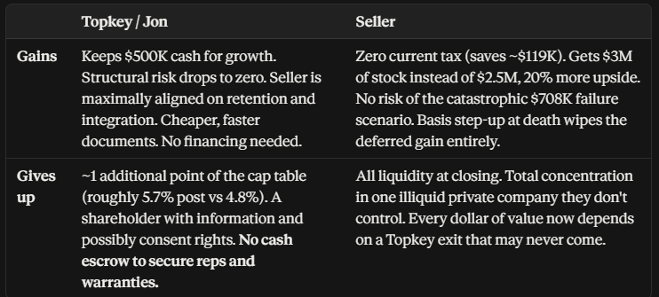

Forward triangular merger — 368(a)(2)(D) — most likely fit
Topkey forms a merger sub, Keystone merges into it and disappears, seller gets Topkey shares plus cash.
- Requires stock to be at least ~40% of consideration under the continuity-of-interest rules (the IRS advance-ruling guideline is 50%). You're at 83%, so you have enormous cushion.
- Requires the sub to acquire "substantially all" of Keystone's assets. Not a problem in a going-concern deal.
- Downside: Keystone as a legal entity ceases to exist. Every client engagement letter, lease, vendor contract, and payroll registration needs to survive the merger. In a bookkeeping firm with 80 people and a large client base, review the assignment and change-of-control clauses. Statutory merger generally transfers by operation of law, which helps, but check anti-assignment language.

Reverse triangular merger — 368(a)(2)(E) — works, but tight
Merger sub merges into Keystone, Keystone survives as a Topkey subsidiary. Better for preserving contracts and licenses.
- The catch: requires that stock representing at least 80% control of Keystone be exchanged solely for voting stock. That caps boot at 20%.
- You're at 16.67%. That's only 3.3 percentage points of margin.
- A working capital true-up, an escrow release paid in cash, buyer covering the seller's legal fees, or a small cash sweetener during negotiation can push you over 20% and blow the whole structure. Then the seller is taxed on the full $3M.
- If you go this route, put a hard cap in the agreement: total cash and non-stock consideration cannot exceed a stated dollar figure. Build the guardrail into the documents.

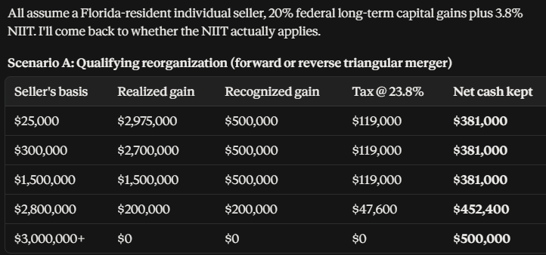
1. Pre-closing distribution of AAA. If Keystone is holding excess cash, distributing it to the shareholder before closing is tax-free to the extent of AAA and basis. Receiving that same cash as merger boot costs 23.8%. On $500K that's a $119K swing. The purchase price gets adjusted down and the working capital peg gets reset, so it's not free money, but it converts taxed dollars into untaxed ones. Two cautions: step-transaction risk if it's too integrated with the merger, and it reduces basis, which increases the deferred gain later. Have the tax advisor model it.
2. Check whether the NIIT applies at all. The 3.8% net investment income tax generally doesn't hit gain from disposing of an interest in an active trade or business where the taxpayer materially participated. If the Keystone owner has been running the firm day to day, Section 1411(c)(4) may exclude the gain. That drops the rate from 23.8% to 20% and saves $19,000 on the boot. Worth the phone call.
3. Cap the boot contractually. If you use a reverse triangular merger, the 20% ceiling is unforgiving. Write a hard dollar cap on non-stock consideration into the merger agreement and make every cash element (escrow, true-up, expense reimbursement, non-compete) count against it.
5. File an 83(b) if the shares vest. If any portion of the Topkey stock is subject to vesting, forfeiture, or a clawback, the seller has 30 days from issuance to file an 83(b) election. Miss it and they're taxed at ordinary rates on the appreciation as it vests. This is the single easiest way to turn a good deal into a disaster, and it's missed constantly.
6. QSBS on the new shares, worth investigating. Section 1202 requires stock acquired at original issuance in exchange for money or property. Stock received in exchange for stock generally doesn't qualify, and the carryover rule in 1202(h)(4) only helps if the original stock was QSBS, which S corp stock never is. But if the transaction is structured so the seller receives Topkey shares in exchange for assets or LLC interests rather than stock, and Topkey meets the qualified-small-business gross assets test at issuance (note: gross assets, not valuation, so a $50M-valuation software company may well be under the threshold), there could be a path. This conflicts with the reorg structure, so it's an either/or, not a both. Flag it for the tax advisor to evaluate. If Topkey is capital-light, the seller's $2.5M could grow tax-free.
Stock vs. Asset Tradeoff (Not Applicable Here)
In a 368 reorganization, Topkey gets carryover basis. No step-up, and no Section 197 amortization on roughly $2.9M of goodwill. At a 21% federal rate plus Florida's 5.5%, that's about $770K of nominal tax deductions given up, present-valued somewhere around $450-500K.
Two implications:
If Topkey is profitable and paying tax, that's a real concession, and your client should extract something for it: a lower headline price, better rep and warranty terms, a longer non-compete, a tighter earnout.
If Topkey is a loss-making venture-backed software company sitting on NOLs, the step-up is worth very little to them for years. Which means the reorg costs your client almost nothing and saves the seller several hundred thousand dollars. That's leverage. Your client can offer the tax-efficient structure as a meaningful concession and trade it for something they actually want on price or terms.
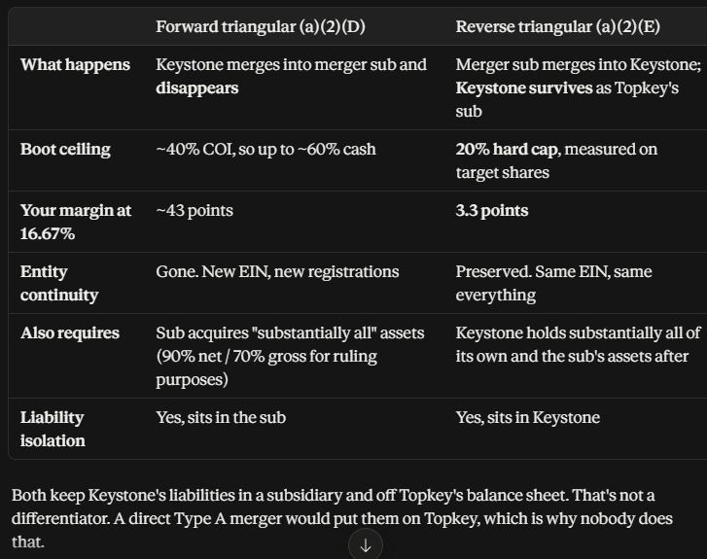

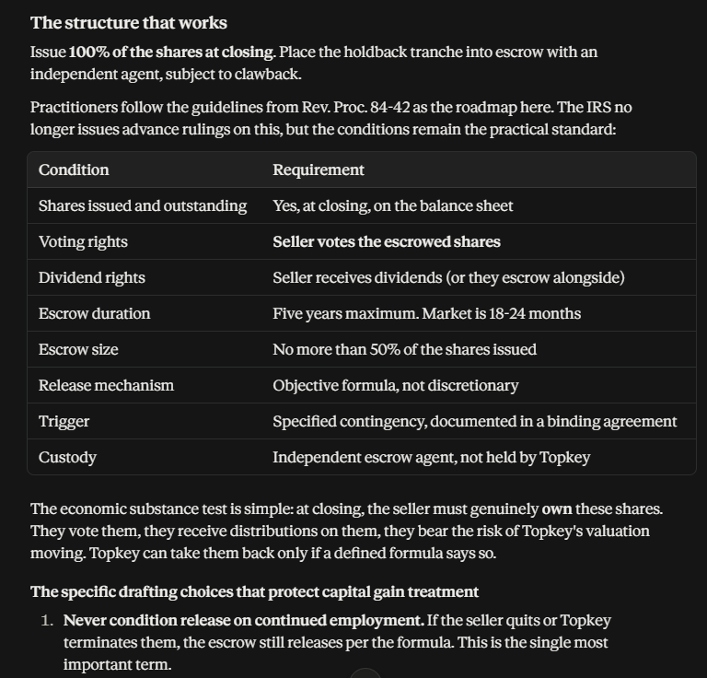
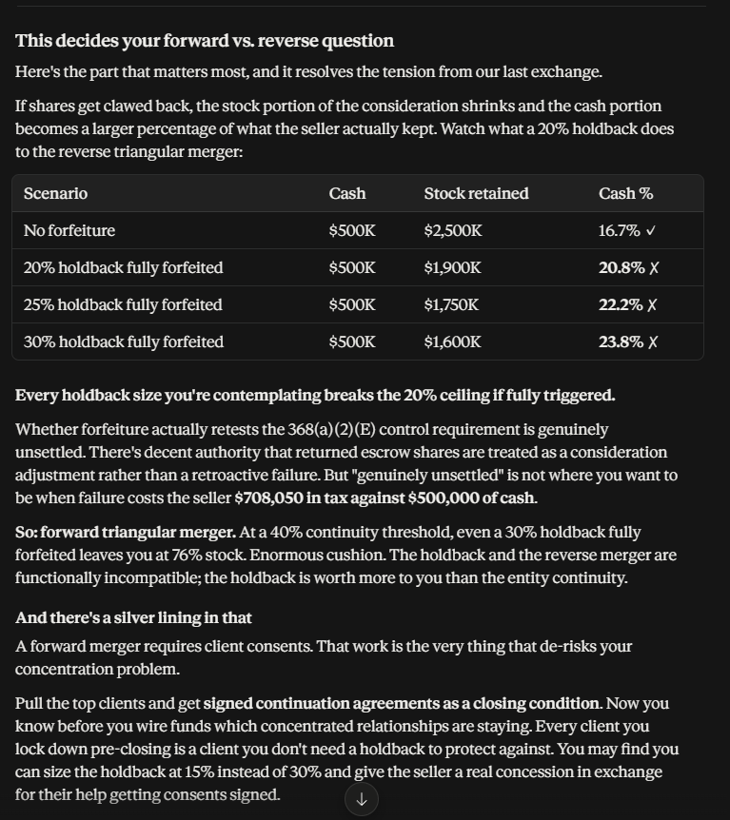

Terms to negotiate carefully
Carve-outs. Forfeiture shouldn't trigger for client losses outside the seller's control:
- Topkey-initiated price increases, service changes, or staff terminations
- Client bankruptcy, acquisition, or ceasing operations
- Topkey's failure to perform
- Migration to a Topkey platform that the client rejects
Write these tightly. They're where the disputes live.
Measurement. Revenue-based, not logo-based. Losing one client at 12% of revenue matters more than losing five at 1%. Define the measurement period (trailing twelve months at the test date is standard) and name the clients on a schedule attached to the agreement.
Two tranches. 50% released at 12 months, 50% at 24 months. Front-loads some certainty for the seller, extends your protection.
Share count, not value. Specify that forfeiture returns a fixed number of shares. Otherwise you'll be arguing about Topkey's valuation at the test date on top of everything else.
Information rights. The seller needs access to the revenue data to verify the calculation, plus a dispute mechanism with an independent accountant.

Keep the indemnity escrow separate
Your reps and warranties escrow is a different instrument, covering different risk: unpaid payroll tax, worker misclassification across 80 employees, E&O on prior engagements, undisclosed liabilities. Market is 5-10% for 12-18 months. Don't collapse it into the retention holdback, because the release conditions and the survival periods are different.
And note that R&W insurance doesn't help here. It covers breaches of representations about the past, not future business performance. Client attrition is a business risk, not a rep breach.
So your total holdback picture might be 10% retention plus 7.5% indemnity, not a single 30% bucket.
Your cash/stock split is uncomfortably close to a hard line in a reverse triangular merger. An RTM under §368(a)(2)(E) requires the acquirer to obtain control — 80% of voting power and 80% of each class of nonvoting stock — in exchange for voting stock. That caps boot at 20%. At $500K cash on $3M, you're at 16.7% — qualifying, but with almost no cushion. If the price adjusts down, the cash portion creeps up, or a working capital true-up gets characterized as additional consideration, you can blow qualification and make the entire transaction taxable to the seller. A forward triangular merger under §368(a)(2)(D) has no 80% requirement — only the general continuity-of-interest standard, generally satisfied around 40%+ stock — so it gives you real headroom. The trade-off is that a forward merger is an asset transfer under state law: Keystone ceases to exist, and you inherit the consent and re-papering burden across client contracts and employment arrangements. That's the actual forward-vs-reverse decision for you, and it's a consent-burden-vs-boot-cushion trade, not primarily a tax one.

